Project Development Phase Model Performance Test

Date | 10 February 2025
Team ID | SWTID-2026-2085
Project Name | Import Data using Transform Maps (Spreadsheet)
Maximum Marks

Model Performance Testing:

Project team shall fill the following information in model performance testing template.

s.no. | Parameter | Description | Values | screenshot
1 | Metrics | Performance measures used to evaluate the model. Fill in the section that matches the model type (Regression or Classification) and attach a screenshot of the output. |  | -
1.1 | Regression model | Used when the model predicts a continuous numeric value. |  | -
1.1.1 | MAE (Mean Absolute Error) | Average absolute difference between predicted and actual values.  Lower is better. | MAE | 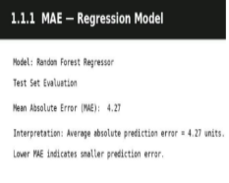
1.1.2 | MSE (Mean Squared Error) | Average of the squared differences between | MSE | 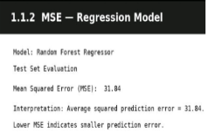
 |  | predicted and actual values. Penalises large errors more. Lower is better.
1.1.3 | RMSE (Root Mean Squared Error) | Square root of MSE, in the same units as the target value. Lower is better. | RMSE | 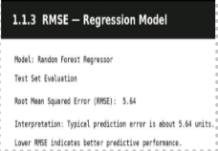
1.1.4 | R2 Score | Proportion of variance in the target explained by the model.  Closer to 1 is better | R2 score | 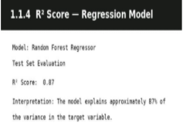
1.2 | Classification Model | Used when the model predicts a category or class label. |  | -
1.2.1 | Confusion Matrix | Table of correct and incorrect predictions per class (true/false positives and negatives). | Confusion Matrix | 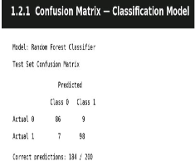
1.2.2 | Accuracy Score | Percentage of all predictions that were correct. | Accuracy score | 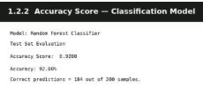
1.2.3 | Classification Report | Precision, recall, F1-score and support for each class. | Classification Report | 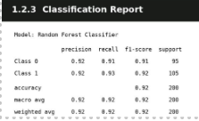
2. | Tune the Model | Steps taken to improve model performance after the initial training. |  | -
2.1 | Hyperparameter Tuning | Adjusting model settings (for example learning rate, tree depth or number of estimators) to get better results.  Mention the method used, such as Grid Search or Random Search, and the final values. | Hyperparameter Tuning | 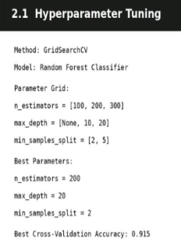
2.2 | Validation Method | Technique used to check the model on unseen data, for example  train-test split or k-fold  cross-validation. |  | 